LED Bulb 4W B22 Candle Bulb
SKU: T527 – 3000k | T528 – 6500k
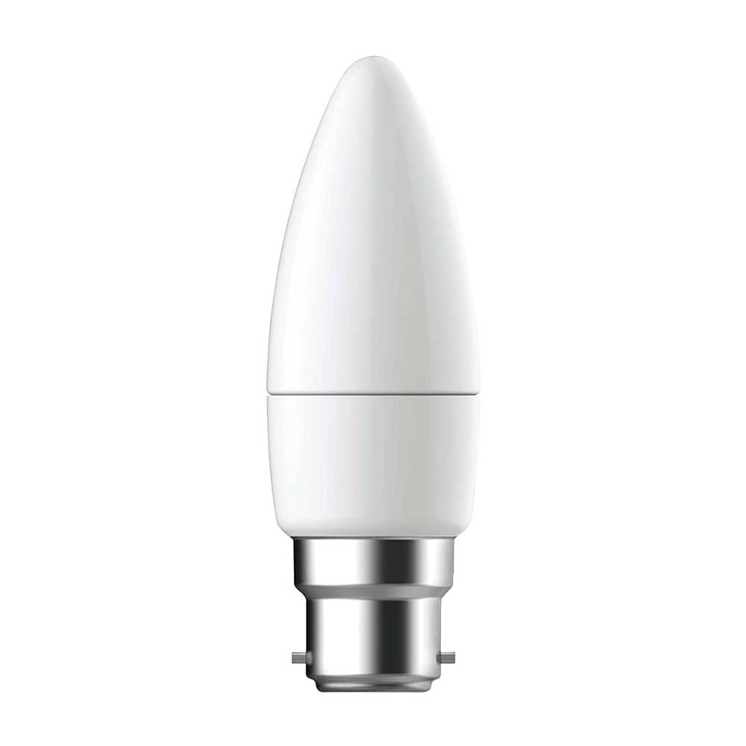
Features
- High quality LED light with superior materials.
- Create a cosy and warm environment similar to halogen or incandescent lamps.
- Very low energy consumption - saves up to 80% energy.
- Sustainable energy saving bulb - lasts up to 20000 hours.
- High colour rendering (CRI > 80) provides vivid colour and extra warm light effect.
- High quality LED light with superior materials.
- Create a cosy and warm environment similar to halogen or incandescent lamps.
- Very low energy consumption - saves up to 80% energy.
- Sustainable energy saving bulb - lasts up to 20000 hours.
- High colour rendering (CRI > 80) provides vivid colour and extra warm light effect.
Specification
SKU | T527 – 3000k  T528 – 6500k
Product Weight | 59 g
Product Dimensions | 5.8 x 10.4 x 17.5 cm
Style | B22 - Bayonet Cap
Shape | Candle
Material | Glass
Voltage | 175-245V
Type of Bulb | LED
Cap Type | B22
EU Energy Efficiency Label | A+
Luminous Flux | 320 lumen
Wattage | 4 watts
Lamp Power Factor | 0.6
Colour Temperature | T527 – 3000k  T528 – 6500k
Colour Rendering Index (CRI) | 80.00
Average Life | 15000 hours
Bulb Diameter | 35 millimeters
Bulb Length | 104 millimeters

